21BDS0340

Abhinav Dinesh Srivatsa

Information Security Management

Assignment – III

**Question 1**

**Aim**

The monitor packets using the Wireshark software and understand the colour coding

**Procedure**

1. Open the Wireshark software
2. Type various filters to analyse the packets

**Screenshots and Results**

TCP packet screen shots. The black background with red text means the packet has a potential problem. The light purple is TCP packets and the grey means TCP SYN/FIN packets.

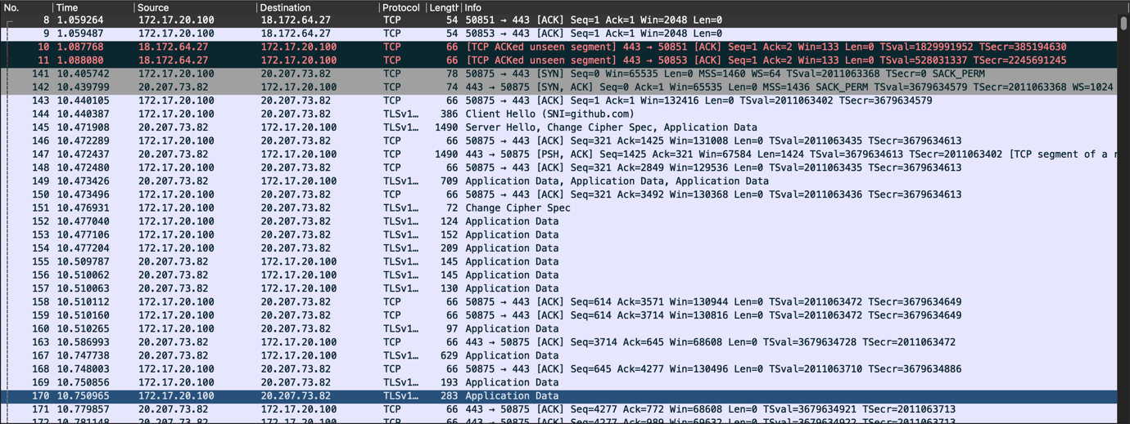

These are UDP packets, coloured by light blue.

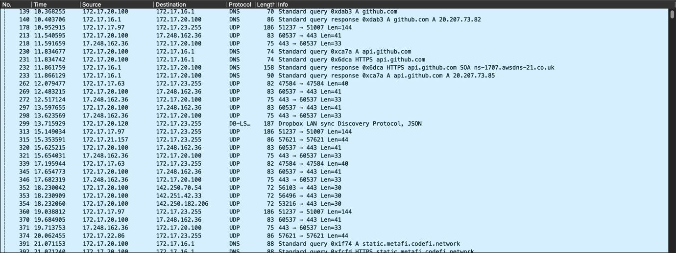

The following are UDP QUIC packets.

The following are HTTP packets:

The following are DNS packets, which uses UDP underneath, hence the same colour:

The following are ARP packets:

**Conclusion**

The colour coding and packet sniffing has been better understood using the Wireshark software.

**Question 2**

**Aim**

To configure a VPN tunnelling connection between two routers

**Procedure**

1. Select 3 1841 routers
2. Connect the routers, the middle one will act as a discovery router between router 1 and 3
3. Connect 2 PCs to the routers 1 and 3
4. Configure IP addresses on all routers and default routing
5. Configure VPN tunnelling between the routers
6. Test the connection

**Screenshots**

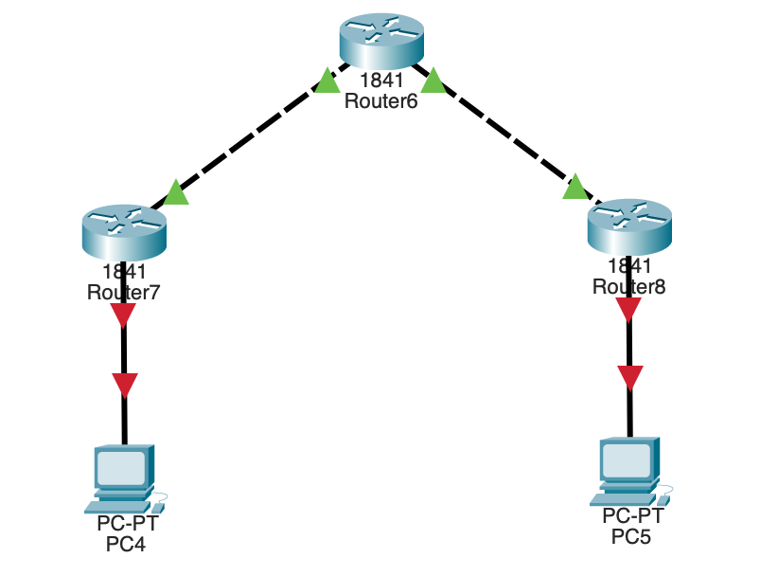

Ping Router 3 from Router 1

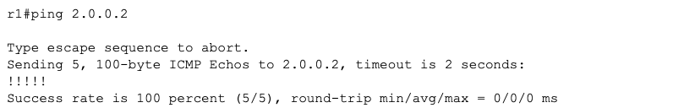

Ping Router 1 from Router 3

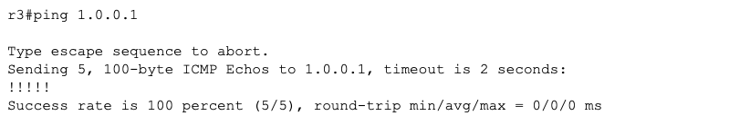

Router 1 Tunnel Configuration

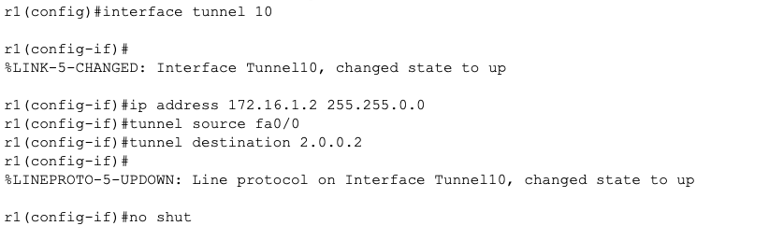

Router 3 Tunnel Configuration

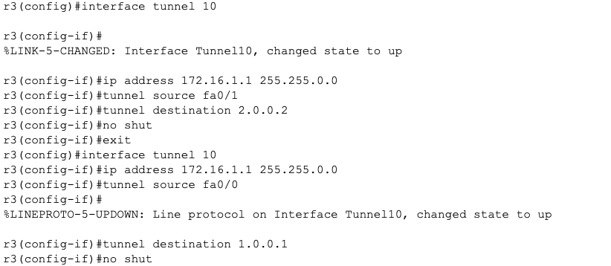

Ping Router 3 from Router 1

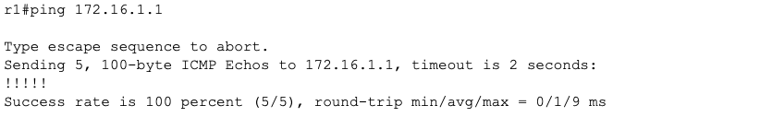

Ping Router 1 from Router 3

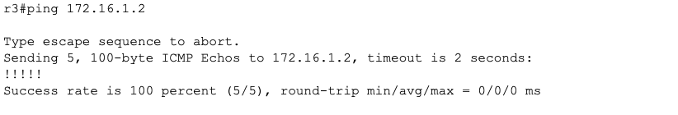

Setting up VPN Tunnel:





**Results**

Viewing Router 1 Tunnel

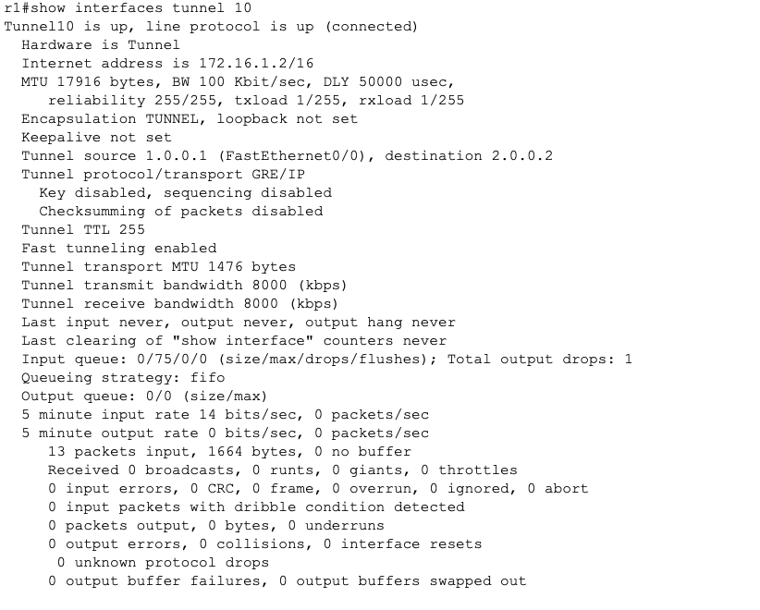

Viewing Router 3 Tunnel

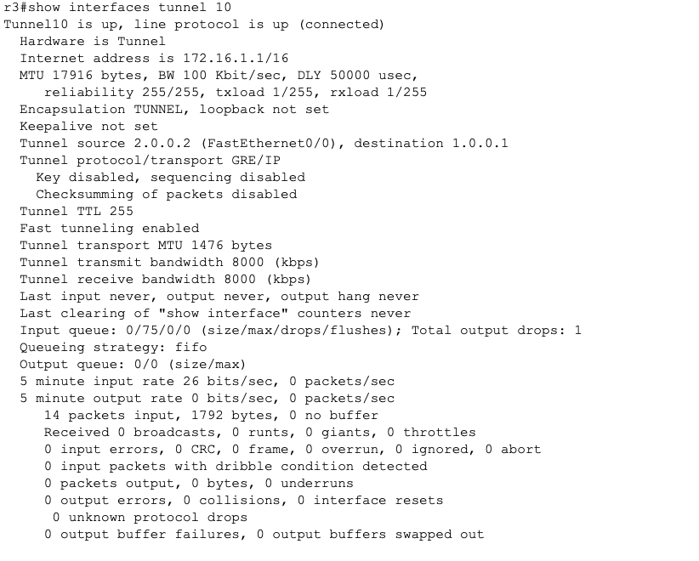

**Conclusion**

This packet tracer demo has been constructed to successfully demonstrate the connection of two networks (routers) using a VPN tunnelling mechanism.